Old Testament Stories

About the Old Testament
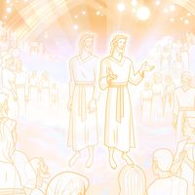

Genesis 1–2; Moses 1–3; Abraham 3–5
The Creation of the Earth
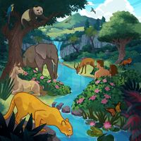

Genesis 2–3; Moses 3–5; Abraham 5
Adam and Eve
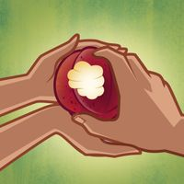

Genesis 4; Moses 5–6
Adam and Eve’s Family
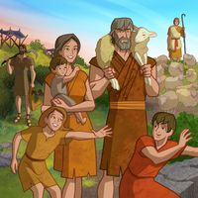

Genesis 5; Moses 6–7
Enoch the Prophet
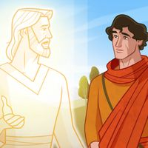

Genesis 6–9; Moses 8
Noah and His Family
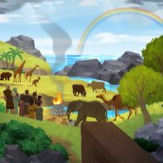

Genesis 11
The Tower of Babel
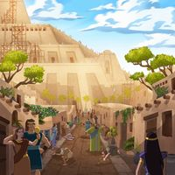

Genesis 11–15; 17; Abraham 1–2
Abraham and Sarah
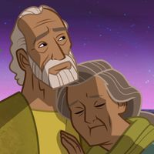

Genesis 16
Hagar
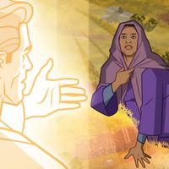

Genesis 17; 21–22
Abraham and Isaac
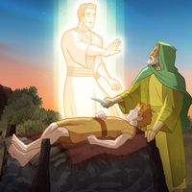

Genesis 25–27
Jacob and Esau
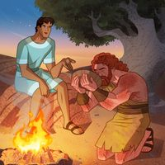

Genesis 27–33
Jacob and His Family
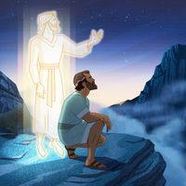

Genesis 30; 37
Joseph’s Inspired Dreams
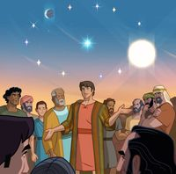

Genesis 39–41
Joseph in Egypt
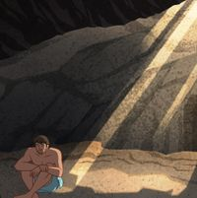

Genesis 42–46
Joseph and the Famine
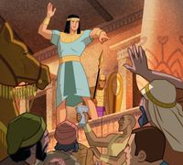

Exodus 1–2
Baby Moses
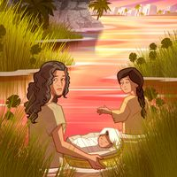

Exodus 2–3
Moses the Prophet
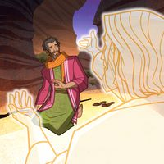

Exodus 4–5; 7–12
The Plagues of Egypt
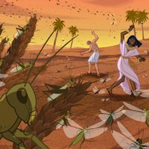

Exodus 11–12; 14–15
The Passover
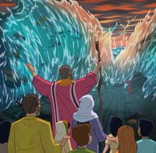

Exodus 16
The Israelites in the Wilderness
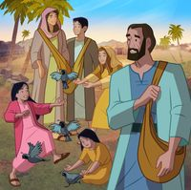

Exodus 19–20; 24; 31–34; Deuteronomy 4–7
Moses on Mount Sinai
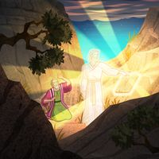

Numbers 21
Moses and the Brass Serpent
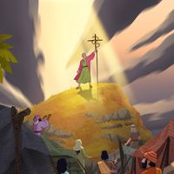

Deuteronomy 10; 31; 34; Joshua 1; 3–6; 10–11; 21; 24
Joshua the Prophet
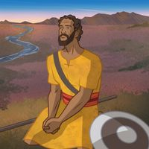

Joshua 2; 6
Rahab and the Spies
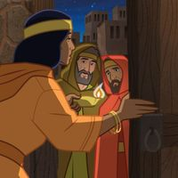

Judges 4–5
Deborah the Prophetess
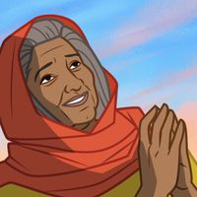

Judges 6–7
The Army of Gideon
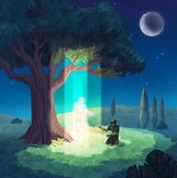

Ruth 1–4
Ruth and Naomi
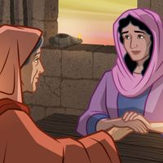

1 Samuel 1–2
Hannah
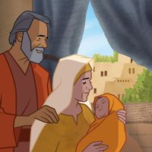

1 Samuel 2–3
Samuel the Prophet
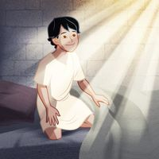

1 Samuel 16
Young David
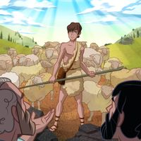

1 Samuel 17
David and Goliath
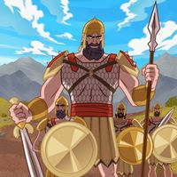

1 Samuel 18–19; 31; 2 Samuel 1; 5; 11–12
King David
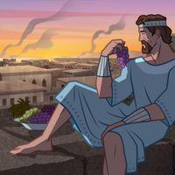

1 Kings 16–18
Elijah the Prophet
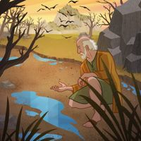

1 Kings 18
Elijah and the Priests of Baal
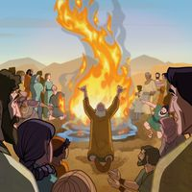

1 Kings 19
The Lord Speaks to Elijah
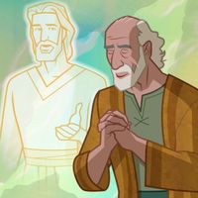

2 Kings 2; 4
Elisha the Prophet
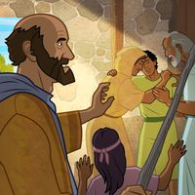

2 Kings 5
Elisha Heals Naaman
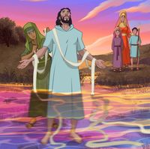

2 Kings 6
Elisha and the Lord’s Army
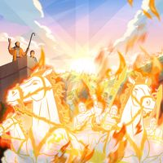

Jonah 1–4
Jonah the Prophet


Job 1–3; 19; 38–42
Job
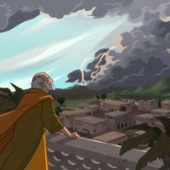

2 Kings 22; 2 Chronicles 34–35
King Josiah
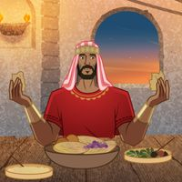

Isaiah 6–7; 9; 53–54
Isaiah the Prophet
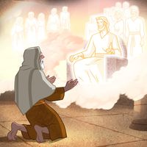

Jeremiah 1–52
Jeremiah the Prophet
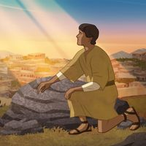

Daniel 1
Daniel and His Friends
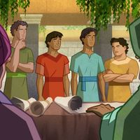

Daniel 2
Daniel and the King’s Dream
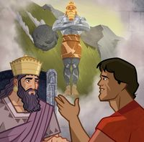

Daniel 1; 3
Shadrach, Meshach, and Abed-nego
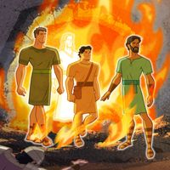

Daniel 6
Daniel and the Lions’ Den
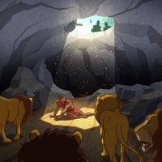

Esther 2–5; 7–9
Queen Esther


Malachi 1; 3
Malachi the Prophet
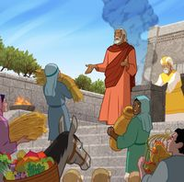

Nehemiah 1–2; 4; 6
Nehemiah
